https://turgotlimoges.scenari-community.org/STI2D/ETLV/Sustainable%20development_web/co/Activite_2.html
Activity 2
VI - Look at the following pie chart.
It represents SUSTAINABLE DEVELOPMENT.

Objectives
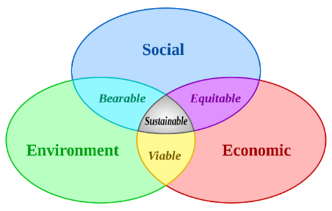 | Sustainable development is a new concept of economic growth which provides fairness and equal opportunities for every citizen in the world. This scheme needs to reach its goals without exhausting finite natural resources. It means doing development without damaging or affecting the environment. It must not compromise the ability of future generations to meet their needs.
Sources: https://en.wikipedia.org/wiki/Sustainable_development

As you can see there are 3 oval shapes that are intertwined/interlocked, if you want to develop a new sustainable product you must respect the three pillars “Social”, “environment” and “economic”.
“Everyone wants a better world: a better environment, a better economy, a better society”

Match the following propositions «People want …» with the three pillars:

Pillars |  |  | People want …
Environment |  | drinking water
Environment |  | leisure facilities
Environment |  | jobs
Environment |  | clean areas.
Environment |  | reasonable prices
Environment |  | access to health services
Environment |  | a safe neighbourhood
Economic |  | green spaces and play areas.
Economic |  | hobbies, sport, cultural facilities
Economic |  | less litter
Economic |  | cheaper heat and light
Economic |  | reliable public transport
Social |  | less pollution
Social |  | be well paid
Social |  | education for everyone
Social |  | to preserve resources for future generations
Social |  | less noise
Social |  | good work conditions
Social |  | decent houses
Social |  | access to food at a fairer price

VII – Some examples of products and services from sustainable development
Complete the three identity cards of the following three activities B, C and D.
For each proposition, say if the three pillars are respected (by writing yes or no) and explain. Conclude by saying if these activities are sustainable.
Look at the example:
- Electrical scooter hire | 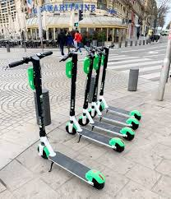
Town Centre – €3.25 for a journey of 15 minutes
Economic | Yes - Creation of an economic activity | Environment | Yes – less pollution and less noise
Social | No – Expensive compared to the bus, in Dublin, f.i. €1.80 for a bus ride without any discount | Sustainable Development | Yes – It s a sustainable activity which offers an alternative to the car. But the price is expensive, it has to adapt the price to poor people.

- Hyde park | 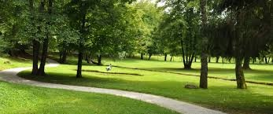
London Centre – free entry
Economic |  | Environment
Social |  | Sustainable Development

- Eco – Hotel | 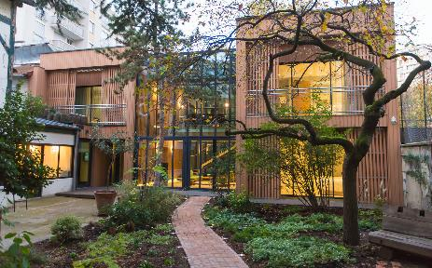  https://qbichotels.com/london-city/stay-green-london/
London
150 € for a night
Economic |  | Environment
Social |  | Sustainable Development

- Green T-Shirt | 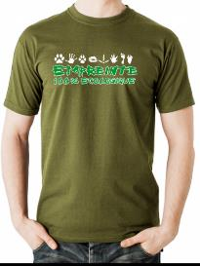  https://www.green-shirts.com/en/about-us
30 €
FairTrade – organic cotton
Economic |  | Environment
Social |  | Sustainable Development

